SIT314/SIT729 – Week 7 Group Activity
Designing Event Loops

Overview

The aim of the task is to identify event loops in a driver-less smart car.

Tasks

Do the following for 3 different event loops.

- Inputs needed
  - What sensors are needed if specific discrete data is needed?
  - What services are needed to be called for input?
  - What state needs to be updated by the event-loop?
- Output
  - What actuations are needed if specific actuation is needed?
  - What services are needed to be called for actuation?
- What processing is needed to make the output decisions?

To help you, think about Sense-Think-Act.

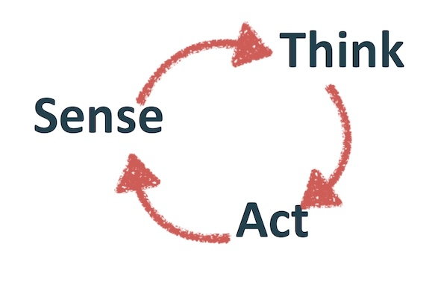
Produce pseudo-code: for each loop.

Event Loop 1 – Collision Avoidance

A - Inputs needed
- Sensors: LiDAR and radar sensors are needed to detect objects and measure their distance and velocity. Additionally, stereo cameras or vision systems are used to identify the type of object (e.g., pedestrian, another car, or a static object).

- Services: The car's mapping service is called to get information about the road ahead, while the GPS service provides the car's current location and speed.

- State: The loop updates the vehicle's state, including the current speed, acceleration, and the distance to the nearest detected obstacle.

B – Output
- Actuations: If an obstacle is detected within a critical distance, the brakes are actuated to slow down or stop the car, and the steering system is adjusted to swerve to avoid the collision if possible.

- Services: The vehicle control service is called to send commands to the braking and steering actuators.

- Processing: The system processes the sensor data to calculate the time to collision (TTC). This requires processing the distance and velocity of both the car and the detected object to determine if a collision is imminent.

C – Event Loop Pseudo Code

LOOP "Collision_Avoidance_Loop":
SENSE:
GET data from LiDAR, radar, and cameras
THINK:
IF obstacle_detected:
CALCULATE time_to_collision (TTC)
IF TTC < critical_threshold:
DECIDE to brake and/or swerve
ACT:
IF DECISION is brake:
CALL vehicle_control_service.apply_brakes()
IF DECISION is swerve:
CALL vehicle_control_service.adjust_steering()
END LOOP

Event Loop 2 – Traffic Ligh Recognition

A – Inputs needed
- Sensors: A vision system or camera is the primary sensor, capturing images of the road ahead to identify the color and state of traffic lights.

- Services: The GPS service is called to get the car's location, which helps the system anticipate and confirm the presence of traffic lights at intersections.

- State: The loop updates the car's traffic state, specifically whether a red or green light is ahead and how long it has been in that state.

B – Outputs
- Sensors: A vision system or camera is the primary sensor, capturing images of the road ahead to identify the color and state of traffic lights.

- Services: The GPS service is called to get the car's location, which helps the system anticipate and confirm the presence of traffic lights at intersections.

- State: The loop updates the car's traffic state, specifically whether a red or green light is ahead and how long it has been in that state.

C – Event Loop Pseudo Code
LOOP "Traffic_Light_Recognition_Loop":
SENSE:
GET real-time image feed from forward-facing camera
THINK:
PROCESS image to DETECT traffic light and its color
IF traffic_light_color is RED:
DECIDE to stop the car
ELSE IF traffic_light_color is GREEN:
DECIDE to proceed
ACT:
IF DECISION is stop:
CALL vehicle_control_service.apply_brakes()
IF DECISION is proceed:
CALL vehicle_control_service.apply_throttle()
END LOOP

Even Loop 3 – Lane Keeping Assist

A – Inputs needed
- Sensors: Lane-tracking cameras or a vision system are used to identify the lane markings on the road.

- Services: The GPS service and mapping service are called to provide context on the type of road (e.g., highway, city street) and the expected lane curvature.

- State: The loop updates the car's lane position state, including its lateral distance from the center of the lane and its heading relative to the lane markings.

B – Outputs
- Actuations: The steering system is actuated with minor, continuous adjustments to keep the car centered in the lane.

- Services: The vehicle control service is called to send precise steering commands.

- Processing: This involves real-time image analysis to determine the position of the car relative to the lane lines. The system then uses

C – Event Loop Pseudo Code
LOOP "Lane_Keeping_Assist_Loop":
SENSE:
GET image feed from lane-tracking cameras
THINK:
ANALYZE image to DETECT lane markings
CALCULATE lateral_position_error from lane center
IF lateral_position_error > tolerance:
CALCULATE corrective_steering_angle
ACT:
IF corrective_steering_angle is needed:
CALL vehicle_control_service.adjust_steering(corrective_steering_angle)
END LOOP

